## Task 01: Create Packages for Reload Dimension from SA_*

* Use Execute Immediate with Bind Parameters

CREATE OR REPLACE PACKAGE BODY pkg_etl_dim_tariffs_dw

AS

*-- Load Data From Sources table to DataBase*

PROCEDURE load_tmp_tariffs

AS

TYPE tariff IS RECORD

(

tariff_code VARCHAR2 ( 5 )

, tariff_name VARCHAR2 ( 50 )

, tariff_payment_sum NUMBER

, tariff_type VARCHAR2 ( 50 )

, tariff_min_payment NUMBER

, tariff_max_payment NUMBER

);

t_cv SYS_REFCURSOR;

TYPE tariffs IS TABLE OF tariff;

tar_ins tariffs;

tar_up tariffs;

sql_str CLOB;

cur_ins NUMBER;

cur_up NUMBER;

get_value NUMBER;

BEGIN

sql_str := 'SELECT DISTINCT

sa_t.TARIFF_CODE

, sa_t.TARIFF_NAME

, sa_t.TARIFF_PAYMENT_SUM

, sa_t.TARIFF_TYPE

, sa_t.TARIFF_MIN_PAYMENT

, sa_t.TARIFF_MAX_PAYMENT

FROM u_sa_data.tmp_tariffs sa_t

WHERE sa_t.TARIFF_CODE NOT IN (SELECT DISTINCT TARIFF_CODE

FROM u_dw.dw_tariffs)';

cur_ins := ***dbms_sql.open_cursor***;

***dbms_sql.parse*** ( cur_ins

, sql_str

, ***dbms_sql.native*** );

get_value := ***dbms_sql.execute*** ( cur_ins );

t_cv := ***dbms_sql.to_refcursor*** ( cur_ins );

FETCH t_cv

BULK COLLECT INTO tar_ins;

FORALL i IN INDICES OF tar_ins

INSERT INTO u_dw.dw_tariffs ( tariff_id

, tariff_code

, tariff_name

, tariff_payment_sum

, tariff_type

, tariff_min_payment

, tariff_max_payment

, insert_dt )

VALUES ( seq_tariffs.NEXTVAL

, tar_ins ( i ).tariff_code

, tar_ins ( i ).tariff_name

, tar_ins ( i ).tariff_payment_sum

, tar_ins ( i ).tariff_type

, tar_ins ( i ).tariff_min_payment

, tar_ins ( i ).tariff_max_payment

, SYSDATE );

sql_str := 'SELECT DISTINCT

sa_t.TARIFF_CODE

, sa_t.TARIFF_NAME

, sa_t.TARIFF_PAYMENT_SUM

, sa_t.TARIFF_TYPE

, sa_t.TARIFF_MIN_PAYMENT

, sa_t.TARIFF_MAX_PAYMENT

FROM u_sa_data.tmp_tariffs sa_t

MINUS

SELECT DISTINCT

tariff_code

, tariff_name

, tariff_payment_sum

, tariff_type

, tariff_min_payment

, tariff_max_payment

FROM u_dw.dw_tariffs';

cur_up := ***dbms_sql.open_cursor***;

***dbms_sql.parse*** ( cur_up

, sql_str

, ***dbms_sql.native*** );

get_value := ***dbms_sql.execute*** ( cur_up );

t_cv := ***dbms_sql.to_refcursor*** ( cur_up );

FETCH t_cv

BULK COLLECT INTO tar_up;

FORALL j IN INDICES OF tar_up

UPDATE u_dw.dw_tariffs

SET tariff_min_payment = tar_up ( j ).tariff_min_payment

, tariff_max_payment = tar_up ( j ).tariff_max_payment

, tariff_payment_sum = tar_up ( j ).tariff_payment_sum

, update_dt = SYSDATE;

COMMIT;

END load_tmp_tariffs;

END pkg_etl_dim_tariffs_dw;

## 

After updating the data in the source table and restart the package data is changed at stage-level.

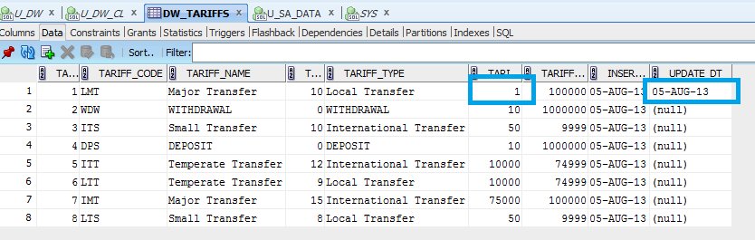

After repeated run the package the data in the table are unchanged. Test results are shown below:

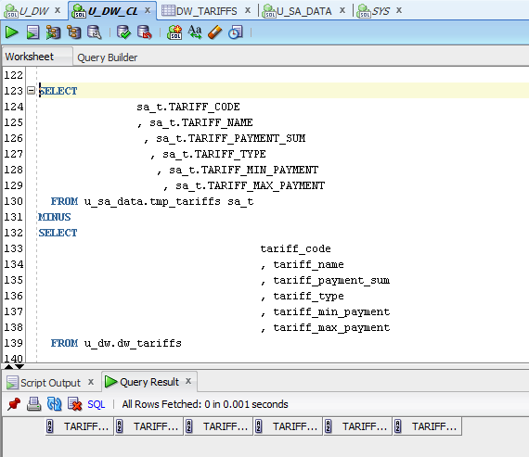

* Use DBMS_SQL.TO_REFCURSOR Function

CREATE OR REPLACE PACKAGE BODY pkg_etl_dim_tar

AS

*-- Load Data From Sources table to DataBase*

PROCEDURE load_tmp_tar

AS

CURSOR c1

IS

SELECT DISTINCT dw_t.tariff_id

, sa_t.tariff_code

, sa_t.tariff_name

, sa_t.tariff_payment_sum

, sa_t.tariff_type

, sa_t.tariff_min_payment

, sa_t.tariff_max_payment

FROM u_sa_data.tmp_tariffs sa_t

LEFT OUTER JOIN

u_dw.dw_tariffs dw_t

ON ( dw_t.tariff_code = sa_t.tariff_code )

WHERE sa_t.tariff_code NOT IN (SELECT DISTINCT tariff_code

FROM u_dw.dw_tariffs);

CURSOR c2

IS

SELECT DISTINCT sa_t.tariff_code

, sa_t.tariff_name

, sa_t.tariff_payment_sum

, sa_t.tariff_type

, sa_t.tariff_min_payment

, sa_t.tariff_max_payment

FROM u_sa_data.tmp_tariffs sa_t

MINUS

SELECT DISTINCT tariff_code

, tariff_name

, tariff_payment_sum

, tariff_type

, tariff_min_payment

, tariff_max_payment

FROM u_dw.dw_tariffs;

TYPE t_ins IS TABLE OF c1%ROWTYPE;

TYPE t_upd IS TABLE OF c2%ROWTYPE;

nt_ins t_ins;

nt_upd t_upd;

sql_ins VARCHAR2 ( 500 );

sql_upd VARCHAR2 ( 500 );

BEGIN

sql_ins := 'INSERT INTO u_dw.dw_tariffs (tariff_id

, tariff_code

, tariff_name

, tariff_payment_sum

, tariff_type

, tariff_min_payment

, tariff_max_payment

, insert_dt)

VALUES (SEQ_TARIFFS.NEXTVAL, :code, :name, :sum, :type, :min, :max, SYSDATE)';

sql_upd := 'UPDATE u_dw.dw_tariffs tar SET tar.tariff_payment_sum=:sum,

tar.tariff_min_payment=:min, tar.tariff_max_payment=:max,

update_dt=SYSDATE

WHERE tar.tariff_code=:code';

OPEN c1;

FETCH c1

BULK COLLECT INTO nt_ins;

FORALL i IN INDICES OF nt_ins

EXECUTE IMMEDIATE sql_ins

USING nt_ins ( i ).tariff_code

, nt_ins ( i ).tariff_name

, nt_ins ( i ).tariff_payment_sum

, nt_ins ( i ).tariff_type

, nt_ins ( i ).tariff_min_payment

, nt_ins ( i ).tariff_max_payment;

OPEN c2;

FETCH c2

BULK COLLECT INTO nt_upd;

FORALL j IN INDICES OF nt_upd

EXECUTE IMMEDIATE sql_upd

USING nt_upd ( j ).tariff_payment_sum

, nt_upd ( j ).tariff_min_payment

, nt_upd ( j ).tariff_max_payment

, nt_upd ( j ).tariff_code;

COMMIT;

END load_tmp_tar;

END pkg_etl_dim_tar;

## 

After updating the data in the source table and restart the package data is changed at stage-level.

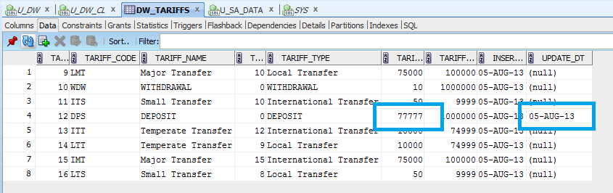

After repeated run the package the data in the table are unchanged. Test results are shown below:

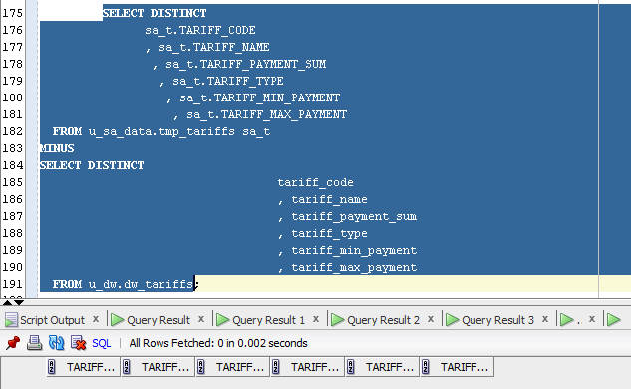

* Use DBMS_SQL.TO_CURSOR_NUMBER Function

CREATE OR REPLACE PACKAGE BODY pkg_etl_dim_currensy_dw

AS

*-- Load Data From Sources table to DataBase*

PROCEDURE load_tmp_currensy

AS

cur_id NUMBER;

column_var NUMBER;

describe_table ***dbms_sql.desc_tab***;

numvar NUMBER;

sql_str VARCHAR2 ( 10000 );

c1 SYS_REFCURSOR;

c_id NUMBER;

c_t_id NUMBER;

c_t_dol NUMBER;

c_name VARCHAR2 ( 5 BYTE );

c_code NUMBER;

c_desc VARCHAR2 ( 50 BYTE );

old_val NUMBER;

BEGIN

sql_str := 'SELECT DISTINCT DW_T.CURRENCY_ID

, SA_T.CURRENCY_TYPE_ID

, SA_T.CURRENCY_TO_DOLLAR

, SA_T.CURRENCY_NAME

, SA_T.CURRENCY_CODE

, SA_T.CURRENCY_DESC

, DW_T.CURRENCY_TO_DOLLAR old_value

FROM u_sa_data.TMP_CURRENCY SA_T

LEFT JOIN u_dw.DW_CURRENCY DW_T

ON ( SA_T.CURRENCY_CODE = DW_T.CURRENCY_CODE )';

OPEN c1 FOR sql_str;

cur_id := ***dbms_sql.to_cursor_number*** ( c1 );

***dbms_sql.describe_columns*** ( cur_id

, column_var

, describe_table );

***dbms_sql.define_column*** ( cur_id

, 1

, c_id );

***dbms_sql.define_column*** ( cur_id

, 2

, c_t_id );

***dbms_sql.define_column*** ( cur_id

, 3

, c_t_dol );

***dbms_sql.define_column*** ( cur_id

, 4

, c_name

, 5 );

***dbms_sql.define_column*** ( cur_id

, 5

, c_code );

***dbms_sql.define_column*** ( cur_id

, 6

, c_desc

, 50 );

***dbms_sql.define_column*** ( cur_id

, 7

, old_val );

WHILE ***dbms_sql.fetch_rows*** ( cur_id ) > 0 LOOP

***dbms_sql.COLUMN_VALUE*** ( cur_id

, 1

, c_id );

***dbms_sql.COLUMN_VALUE*** ( cur_id

, 2

, c_t_id );

***dbms_sql.COLUMN_VALUE*** ( cur_id

, 3

, c_t_dol );

***dbms_sql.COLUMN_VALUE*** ( cur_id

, 4

, c_name );

***dbms_sql.COLUMN_VALUE*** ( cur_id

, 5

, c_code );

***dbms_sql.COLUMN_VALUE*** ( cur_id

, 6

, c_desc );

***dbms_sql.COLUMN_VALUE*** ( cur_id

, 7

, old_val );

IF c_id IS NULL THEN

INSERT INTO u_dw.dw_currency cu ( cu.currency_id

, cu.currency_type_id

, cu.currency_to_dollar

, cu.currency_name

, cu.currency_code

, cu.currency_desc )

VALUES ( seq_currensy.NEXTVAL

, c_t_id

, c_t_dol

, c_name

, c_code

, c_desc );

ELSIF c_t_dol != old_val THEN

UPDATE u_dw.dw_currency

SET currency_to_dollar = c_t_dol;

INSERT INTO u_dw.dw_currency_actions ca ( ca.currency_action_id

, ca.currency_id

, ca.action_date

, ca.currency_action_type_id

, ca.value_old

, ca.value_new )

VALUES ( seq_currensy_action.NEXTVAL

, c_id

, SYSDATE

, 1

, old_val

, c_t_dol );

END IF;

END LOOP;

COMMIT;

END load_tmp_currensy;

END pkg_etl_dim_currensy_dw;

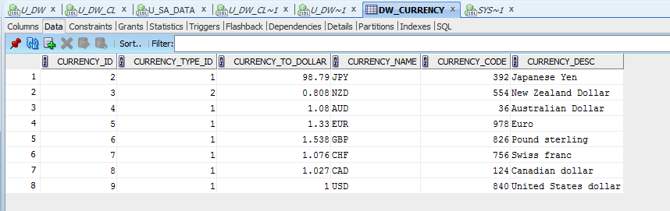

After updating the data in the source table and restart the package data is changed at stage-level.

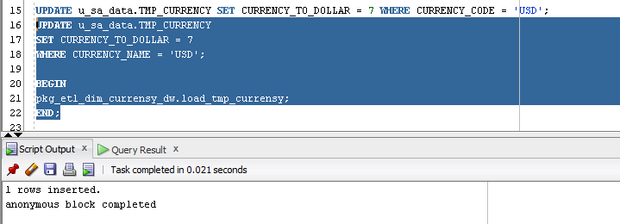

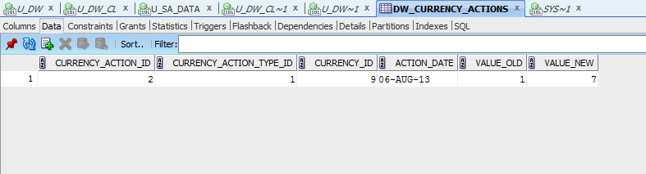

After repeated run the package the data in the table are unchanged. Test results are shown below:

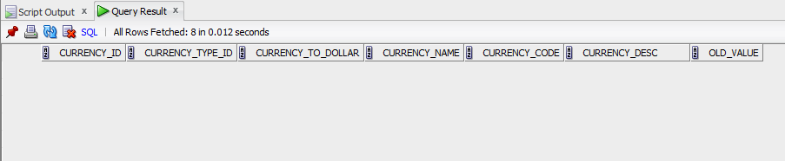

## Task 02: CREATE Monthly Reports Layouts

SELECT event_dt

, tariff_type

, tariff_name

, SUM ( am_sum )

, SUM ( count_tr )

, SUM ( profit )

, SUM ( prg )

FROM ( SELECT event_dt

, tariff_type

, tariff_name

, am_sum

, count_tr

, profit

, prg

FROM ( SELECT TRUNC ( TO_DATE ( event_dt

, 'dd-mon-yy' )

, 'month' )

event_dt

, tariff_type

, tariff_name

, tariff_payment_sum

, SUM ( SUM ( payment_sum / currency_to_dollar ) ) OVER (PARTITION BY tariff_type) par_sum

, ROUND ( SUM ( payment_sum / currency_to_dollar )

, 2 )

am_sum

, COUNT ( payment_sum / currency_to_dollar ) count_tr

FROM u_dw_ext_references.tmp_transactions_info

WHERE tariff_type IN ('Local Transfer', 'International Transfer')

AND tariff_name IN ('Small Transfer', 'Temperate Transfer')

AND TO_CHAR ( TRUNC ( event_dt

, 'YYYY' )

, 'YYYY' ) IN ('2012')

GROUP BY (tariff_type, tariff_name, TRUNC ( TO_DATE ( event_dt

, 'dd-mon-yy' )

, 'month' ), tariff_payment_sum))

MODEL RETURN UPDATED ROWS

PARTITION BY ( tariff_type, tariff_name )

DIMENSION BY ( event_dt )

MEASURES ( 0 prg, 0 profit, am_sum, par_sum, count_tr, tariff_payment_sum )

RULES AUTOMATIC ORDER

( prg [event_dt] = ROUND ( ( 100 * am_sum[CV ( event_dt )] / par_sum[CV ( event_dt )] )

, 5 ),

profit [event_dt] = ROUND ( ( count_tr[CV ( event_dt )] * tariff_payment_sum[CV ( event_dt )] / 100 )

, 2 ) )

ORDER BY 2

, 1

, 3)

GROUP BY ROLLUP ( ( event_dt, tariff_name ) )

, tariff_type;

